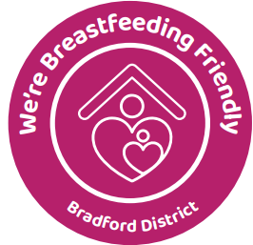
Our Breastfeeding Friendly policy
Action for Community, and specifically Bradford Doulas welcomes babies to be breastfed in any of their premises.
How we will make this happen
All our staff will support the needs and rights of mothers/parents breastfeeding. If another customer or visitor to our premises objects to breastfeeding, they should be told that management supports breastfeeding. If the situation cannot be resolved readily, junior staff should refer customers/visitors to senior management.
- A copy of this policy should be issued to all new staff members and a copy should be displayed in: Unit 16
- Distributing and updating this policy annually is the responsibility of Shelley Franklin-King, Bradford Doulas, Service Manager, who will be glad to hear comments and reports of any incidents.
- If a member of staff feels they need more guidance on this, they should speak to Shelley Franklin-King or any member of the Bradford Doulas staff team

To demonstrate that we are Breastfeeding Friendly, our staff will:
- display stickers and appropriate signage
- make mothers and babies welcome
- display the Breastfeeding Friendly certificate.

Why we are Breastfeeding Friendly
- We support the needs of our customers, visitors or clients and work to ensure we are family friendly.
- Babies have small stomachs so need feeding when they ask for it. Breastmilk is full of nutrients and is digested very quickly.
- Breastfeeding works best when mother and baby are both relaxed.
- Hungry, upset babies will generally be helped to calm down and become quiet when breastfeeding. This is good for all our customers, visitors or clients.

Breastfeeding Friendly Bradford District - Bradford District Care NHS Foundation Trust

